The Rapture Event Will Be Visible & The End of Works Righteousness
May 28, 2016

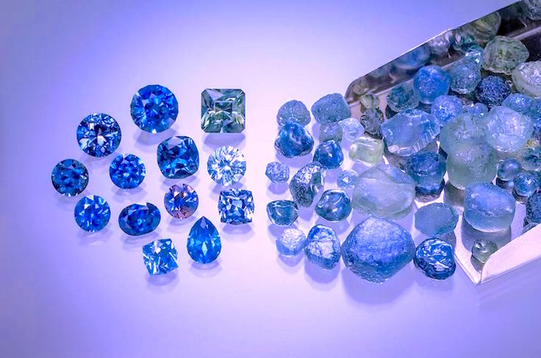
May the great expectation of our catching away with the Lord keep us all in a state of readiness, Heartdwellers!

I just finished watching the Rapture clip I posted from Bob Barber's channel, “What the Rapture Will Look Like - a Detailed Account”. And it was amazing. It was really, really well done, and left us both, Ezekiel and I, speechless.

So, that was on my heart and mind when I came to listen to the Lord.

Jesus began, "You haven't seen anything yet. You think THOSE fireworks were amazing - wait until you see the fullness of what I have planned. It will be far beyond the imaginings of any filmmaker! But I must say, that was a very nice try and certainly gave you all a glimpse of something you never had before.

"David is My faithful servant."

He's referring there to David A.R. White - the filmmaker who did that clip on the Rapture.

"Nonetheless, eye has not seen, ear has not heard. Neither has it entered into the heart of man what I have planned for you, My Bride. It is glorious beyond description and heartrendingly beautiful! These days are filled with uncertainty and challenges. The waiting for some is almost unbearable. Yet My Grace sustains you. All that is beautiful and praiseworthy is hidden behind the veil of filth the enemy has swathed this world with. But for a few, brief moments that veil will be removed and you will see even as you are seen.

"Nothing like this has ever happened, nor will it again - with the exception of the descent of the New Jerusalem. This again will be a moment never to be forgotten for all time.

"How I long for My Bride to be lifted up into the heavenlies! To experience her transfiguration. Eye has not seen, and NEVER has it entered into the heart of man what is about to happen. John the Evangelist saw many glorious things, but this experience will outshine them all.

"What I have planned for you, My Brides, will only be believed when it is seen. Yet even that will be twisted into something the enemy can use. Some, however, will be totally convinced and give their lives to Me. Especially those relatives of the Brides. You've been preparing your families for this, and there will be no escaping that this is truly the fulfillment of that prophecy. This event will leave a permanent imprint that will carry them all the way through until the end. There will no longer be any doubts that I am real and that I will return to rule.

"So many now cannot conceive of this, because they've been conditioned by the world. But this event will change all of that. Only the most hardened hearts will question what just took place, and will be eager to replace it with the world's explanation.

"This is why I resolved to make this a publicly visible event. All the tribes of the Earth will mourn."
At that time, the sign of the Son of Man will appear in Heaven and all the tribes of the Earth will mourn. They will see the Son of Man coming on the clouds of Heaven with power and great glory. Matt 24:30

"The tribes of Israel in particular are referred to here, for they crucified their Messiah, and this will be the point of their breaking. Never again will the reins of pride rule My people. They will be humbled to the very lowest point. The greatest among them will see himself as the greatest sinner, for all the learning of the Scribes and Pharisees never prepared them for the reality of Who I Am. The entire system of righteousness through works will crumble and the prostitute will indeed enter the Kingdom ahead of them.

"Yet, I am not saying this to shame them, so great is My love for My People. I look forward with great longing to the day they realize I AM the heart of the Law and the fulfillment of all the prophets and all that is written. I am more than their Savior - I am the incarnation of the Living God. And through My life on this Earth I have demonstrated the substance of their faith and how I require them to live it.

"Never again will man's worth be judged by his works or earthly value. All the rich of the Earth shall be humbled before My precious Blood, which can never be given a value. The lame and the infirm shall hold a special place before Me as I heal them. Yet the law that decrees these are "unclean" will be washed away forever by My Blood.

"The great ones of the Earth shall be humbled and filled with joy at their lowliness. The poor of the Earth shall be exalted and restored to the very value of life itself. No longer will man judge between this one and that one. All will be purchased with My Blood.

"Clare, the heart of the Law IS Love. Do you understand, My Daughter? There is no "way" to earn a place in My heart. You already have My Blood coursing through your veins and you are priceless to Me. And Love is the currency of Heaven. It is the most valued attribute. And all that walk in Love are priceless gems from My Father’s bosom. They have completed their journey and trials on this Earth and been restored to the purity from which they were created.

"It is a great mystery, this coming of man and returning to the Father. It carries with it a dignity admired by the angels of Heaven and feared by the fallen of Hell. It is as though My very life, death and resurrection is repeated over and over again by those who have given their lives to Me…and truly I do perfect them. They have something the angels can never have. They feel a oneness and union with Me no other creature can attain to.

"Yes, it is a great mystery under which I have given Myself completely to My Creation. Yes, I am the kernel of wheat which fell to the ground and brought about the great fields of ripe wheat for harvest. The perfection of all things created has run its course and returned to Me -yet now with the glory of the individual who has died to self to put on Me. Oh, how many mysteries are tied up in this mystical death. Only in Heaven will you truly be able to understand how I have given up Myself into each and every one of you to live through you, and how by this dying and resurrection you, too, are now little Christs.

"Do not strain to understand. Soon enough it will become clear as crystal to your understanding. But now is still the time of contending with the evil powers of this earth and their foothold on My people. Now is still the time of trial and test, whereby the glory of My life will emanate from those who are victorious. I know none of you feel like a victorious one - but can you trust Me? You are. I know you see so little value in yourselves and in a way that is quite accurate and safe, but in another way it is grossly underestimated.

"Yet for the sake of your salvation it is best to avoid examining these things too closely. While you are yet on the Earth you are still prone to pride, jealousy and the desire to be above others. Your safety is in your littleness and when you can rejoice in that place truly and from the heart, the battle is nearly won.

"I say that because no matter how you appear to others, you still are subject to this condition I have created to safeguard your splendor and beauty in Me.

"So, My Brides, can you rest in that? Can you rest in the vision of being restored to the Father in all your pristine beauty, where your battle scars will shine with the radiance of a diamond never seen before? Yes, take these words to heart. Continue to prepare yourself daily and understand we are partners in this venture. I am perfecting you. You are merely responding to the Master’s hand as He facets the raw beauty of your being into a one of a kind creation. Rest in that. There is nothing more you can do but love at every opportunity, and repent at every failure and follow Me. I know how to motivate and lead you, do not fear for one moment. This is My job, and I do it well.

"May the richness of My indwelling presence be all sufficient for you to run the race to a victorious finish. I, Myself, will see to it."

